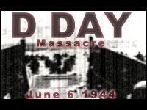
D-Day Massacre

By ScnPunk Team
@ scnnetwork.com

4 player multiplayer scn.

After Extracting move “Data” folder from the package into your Empires : Dawn of the Modern World main folder. Select Yes to overwrite question.

If you have Any Questions or comments e-mail us at scnpunk@hotmail.com

Coming Soon: Imperial Wars and Stalingrad(New Year - Christmas)

Thanks for playing
Ex-T, shykre @ SCNNETWORK

All vocals used in this scenario are sole property of shykre and ScnNETWORK.

